

SYMBIOSIS INSTITUTE OF TECHNOLOGY, PUNE

Symbiosis International (Deemed University)
(Established under section 3 of the UGC Act, 1956)
Re-accredited by NAAC with ‘A’ grade (3.58/4) | Awarded Category – I by UGC

Founder: Prof. Dr. S. B. Mujumdar, M. Sc., Ph. D. (Awarded Padma Bhushan and Padma Shri by President of India)

Assignment No. 05

Subject: | DevOps Lab
TCODE: | TE7950
Name of Student | Atharva Rale
PRN No. | 23070122174
Branch | CSE, Batch (2023-27), L3
Academic Year & Semester | 25 – 26, Sem VII
Date of Performance | 23rd July, 2026
Title of Assignment: | Jenkins Setup & Freestyle Project
Implementation: | Pull the Jenkins Image  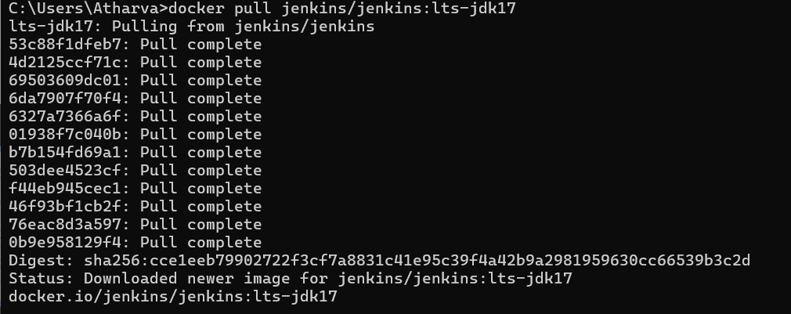  Run the Jenkins Container  Verify Container  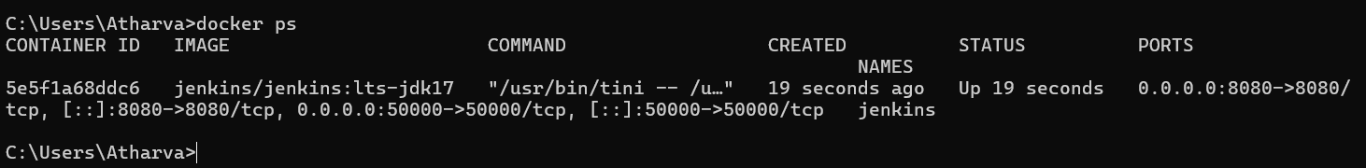

Initial Jenkins Setup

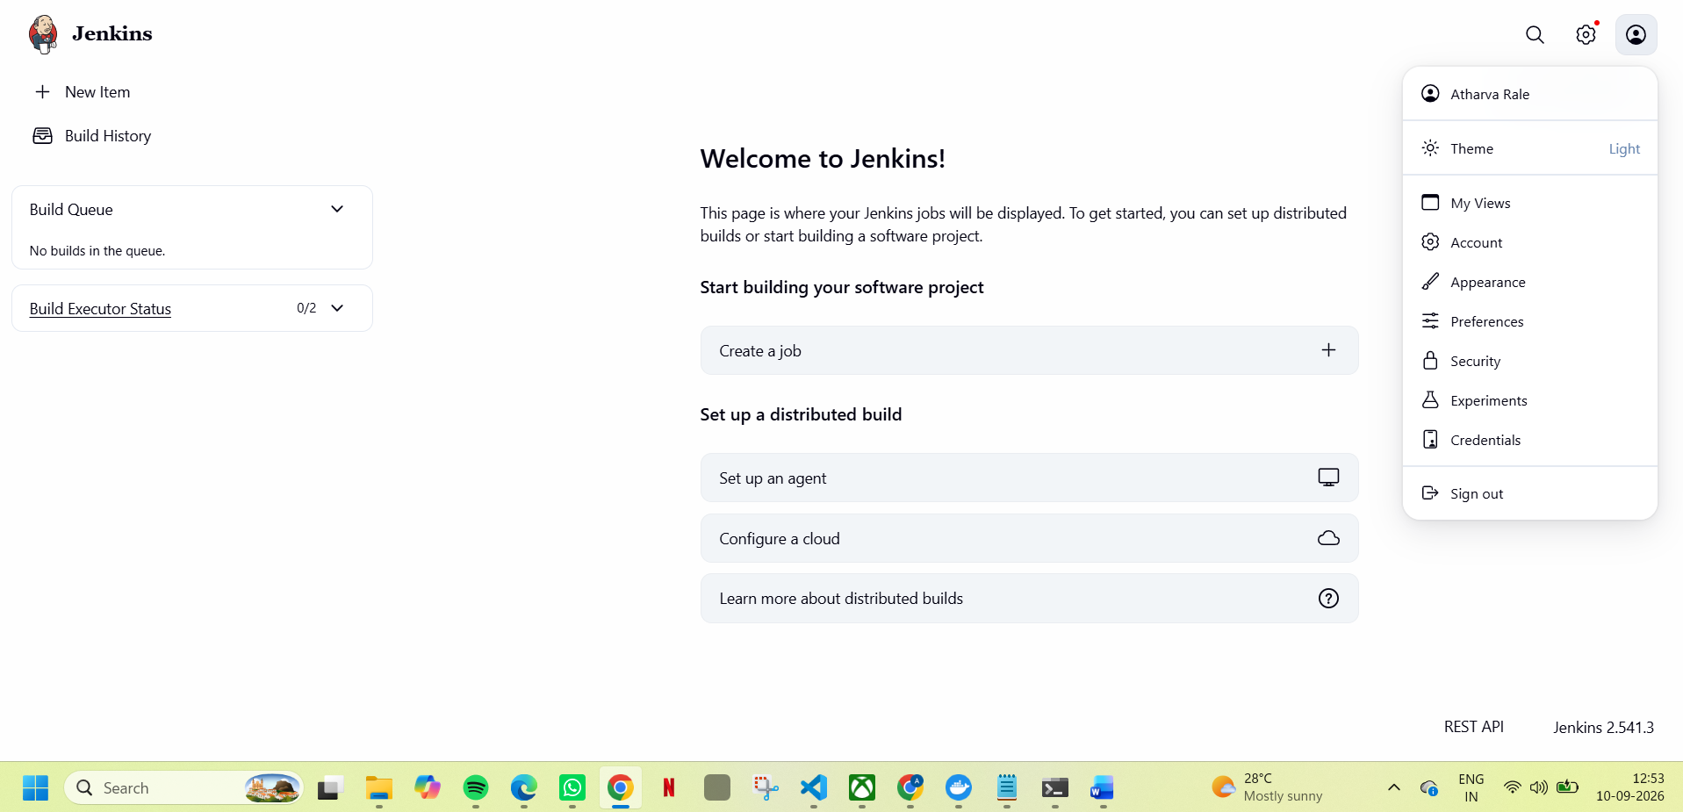

Instance Configuration

Verify Git Plugin Installation

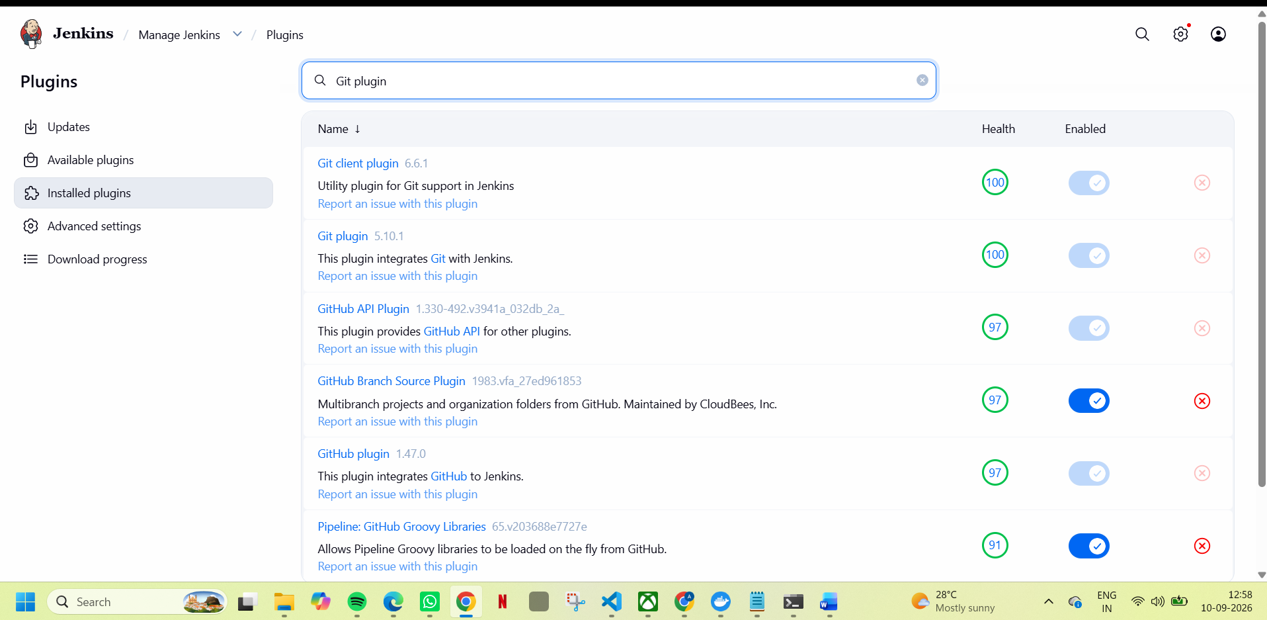

Step 6: Create a Freestyle Project

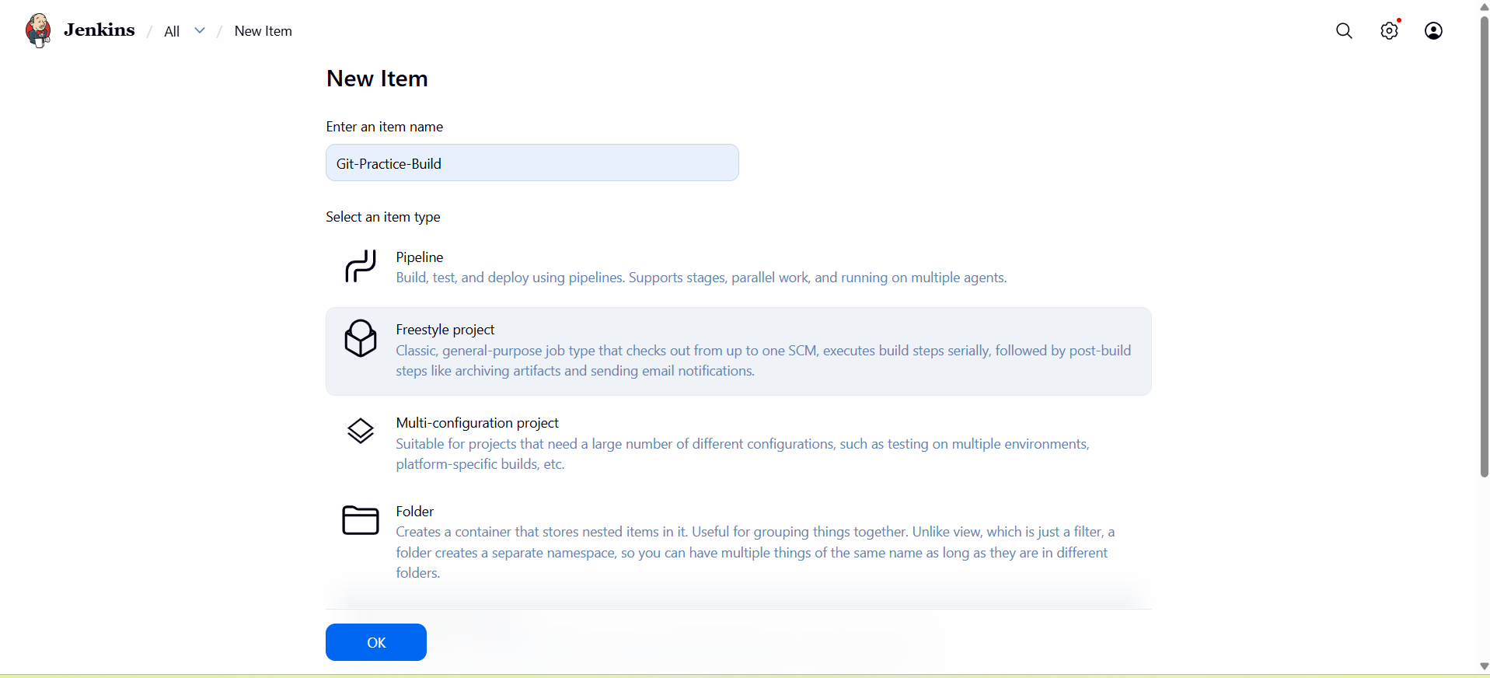

Step 7: Configure Source Code Management (Git)

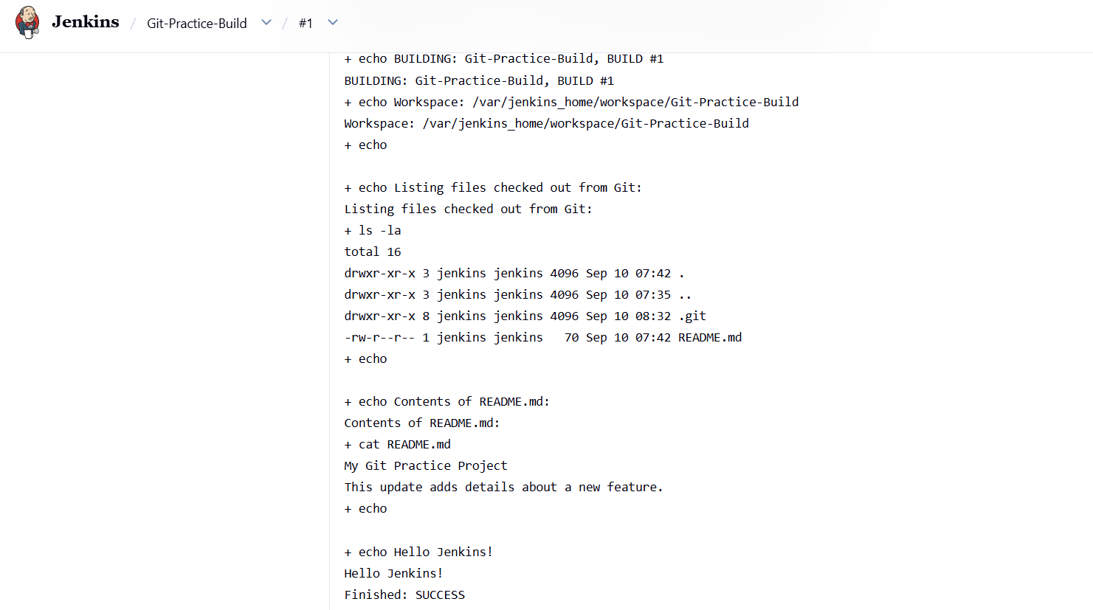

Subject Faculty Name: Prof. Arijit Dutta

